LYNFIELD COLLEGE
2026 STUDENT ASSESSMENT COVER SHEET

Course Title |  |  |  | 2PAD
91897: Use advanced processes to develop a digital technologies outcome
Achievement Standard | 91897 | Level | 2 |  | Version | 1 | Credits | 6

Due Date: Term 3, Day 9, Week 2 (27 July 2026)
Achievement Criteria:

Achieved | Merit | Excellence
Use advanced processes to develop a digital technologies outcome. | Use advanced processes to develop an informed digital technologies outcome. | Use advanced processes to develop a refined digital technologies outcome.

Authenticity statement:

The work that I have submitted for this assessment is my own.
I understand any material used and/or quoted that is not my own must be acknowledged in the appropriate manner. I understand that the use of chatbots, generative AI, paraphrasing tools, or other tools that can automatically generate content is not permitted. Material generated by these tools has not been included in this submission.
I understand any material used and/or quoted that is not my own must be acknowledged in the appropriate manner.
I have acknowledged all direct quotes and references used in this assessment.
I understand that plagiarism and/or collusion with other students may result in disciplinary action and a Not Achieved grade being given.
If submitting a digital copy of this assessment I agree to the above.
I give permission for my assessment to be given to the external assessor for marking.

STUDENT’S NAME: Liam Hohn DATE: ………..

STUDENT’S SIGNATURE .........................................................

Grade awarded:

Not Achieved | Achieved
Merit | Excellence

TEACHER’S SIGNATURE .........................................................

Instructions
- Read all instructions carefully.
- Complete ALL tasks.
- Ensure your name is on every page of your assessment.

Conditions
- The timeframe for completion will be set by your Assessor according to a particular classroom situation.
- You must follow legal ethical and moral responsibilities when creating your documents.

Note to Assessors:

You will need to provide candidates with a copy of the documented policies and procedures or commonly accepted practices of your organisation, prior to being assessed against this achievement standard.
Context/Te Horopaki
This is an integrated assessment activity supporting a project-based approach that assesses against two achievement standards. Students will use advanced processes to plan, test and trial a party hire store program. They are required to implement advanced programming techniques within their hire program.
Using advanced processes will support the students to develop a refined party hire program that has been comprehensively tested and debugged. Both achievement standards require testing to improve the quality and functionality of the outcome.
Students will use python programming language and tkinter, as it supports a range of advanced programming techniques.
Conditions/Ngā Tikanga
You will be given two identified checkpoints with as you work through this assessment activity to ensure they have an opportunity to ask questions and gather feedback.
Resource requirements/Ngā Rauemi
Students will need access to software that will allow them to document their development process. This could be in the form of a document, testing document or google slides.
They will also need access to project management and version control tools (which may include a mixture of digital and non-digital resources).

The format of the final outcome is a computer program.
Students will need to supply evidence of using recognised and appropriate project management tools and techniques to plan and manage the development of the computer program. This will include trialling and testing the components of the program (see student task for more details).

Achieved
Use advanced processes to develop a digital technologies outcome involves:
- using appropriate project management tools and techniques to plan the development of a digital technologies outcome.
- decomposing the outcome into smaller components
- trialling the components of the digital technologies outcome
- testing that the digital technologies outcome functions as intended
- explaining relevant implications.
Merit
Use advanced processes to develop an informed digital technology outcome
involves:
- effectively using project management and version control tools and techniques to
- manage the development of a digital technologies outcome.
- trialling multiple components and/or techniques and selecting those which are
- most suitable
- using information appropriately from testing and trialling to improve the
- functionality of the digital technologies outcome
- addressing relevant implications.
Excellence
Use advanced processes to develop a refined digital technologies outcome involves:
- discussing how the information from planning, testing and trialling of components assisted in the development of a high-quality outcome.

Below are some examples of project management and version control tools and techniques and relevant implications.

Examples of project management and version control tools and techniques include:
● saving backup copies with a logical file naming system
● using collaboration tools
● using simple version control software applications
● using tools or systems to plan tasks and milestones
● adjusting key actions and tasks where appropriate

Examples of relevant implications include:
● social
● cultural
● legal
● ethical
● intellectual property
● privacy
● accessibility
● usability
● functionality
● aesthetics
● sustainability and future proofing
● end-user considerations
● health and safety.

Planning Tools may include:

The template gallery in Google Sheets has Project Management tools for drafting up a plan. They are Gantt Chart, Project Timeline, and Project Tracking. Complete your own research to find a tool that suits you.

Gantt Chart – this is a bar chart that tells a visual story. It is like a visual to-do list. Filling in cells with different colours, using clear labels and headings and breaking down tasks into small chunks helps to determine a robust workflow.

Project Timeline – this is similar in looks to a Gantt Chart. It has clear stages.

Project Tracking – this tool is less visual. It works with task descriptions, start and end dates.

Trello Board: progress tracking with your milestones.

Task size table: estimate of how long your task is.

Also refer to the training education website for more examples.
Other Resources

Project Management Tools and Techniques:

A project has a beginning and an end with lots of steps (tasks, processes) that are completed at various points along the project timeline. In this context, project management tools and techniques are used to document the process of outcome development. Project Management involves planning the steps to take and documenting them as they are taken. Progress is tracked and end users are consulted.

It is important that you do your own research to find a project management tool that suits your workflow. From the standard, examples of project management tools and techniques include:

• Agile or waterfall techniques

• Kanban

• Version control software

• Collaboration tools

NOTE 1: It is not a requirement that you utilise all of these techniques and tools. It is up to you what you use. However, you must use at least one tool to manage your project and Justify it.

NOTE 2: Check the usability of your Project Management Tool. Some tools offer you 30 days free, others restrict the number of cards/boards you can use.

These are software development methodologies.
Agile – continuous iteration. Changes allowed in the project.

Waterfall – sequential order. The project only moves forward if the previous step or phase is complete. Simplest technique for small projects.
https://www.youtube.com/watch?v=egF9-FejbsA

Tools:

Kanban – Kanban is a visual process and project management tool.

Version Control – saving each iteration as the outcome is developed allows the designer to revisit an earlier version at any time.
Collaboration Tools - examples include Trello, Padlet, Figma, Microsoft
Teams, Microsoft Tasks, Microsoft ToDo, Fleep, Monday.com. These can be used to showcase your development for feedback from end users. Google Forms can be used to gather feedback, or a questionnaire created in other software such as Microsoft Word. Choosing the right collaborative tool is important for sharing your development with end users and collecting feedback. Slack, for example, can be integrated with Google Forms.
Google Forms are one way of questioning end users. Responses are automatically collated in a Google Sheet.

Trial and Test

- For each component, trial and test with end users
- Repeat the cycles of trialling (gather information) and testing (make decisions) until you are satisfied that you have iterated enough to have a high-quality outcome.

Reflection

Create a document and save it as ‘Reflection’. Set up headings and discuss the questions as outlined below.
- How has the combination of planning, utilising project management tools, collaboration tools, and feedback tools helped you to create a high-quality outcome?
- How has the information you have gathered from the planning, trialling and testing of components lead to the creation of your final outcome?
- How have you addressed your relevant implications in your final outcome?

The below questions allow you to follow a structured way of approaching the AS91897. Note that where it says (Add answer here) an answer is required. In order to receive an achieved in this project all questions must be answered at a reasonable level (more than just one sentence).

Concept design (Sketch/Draft):

Use the below space to add three sketch/draft concepts of your program. Remember to sketch all windows, images, buttons and text. You can use photos of your hand sketch, lucid charts or other illustrative software to complete this.

Concept 1

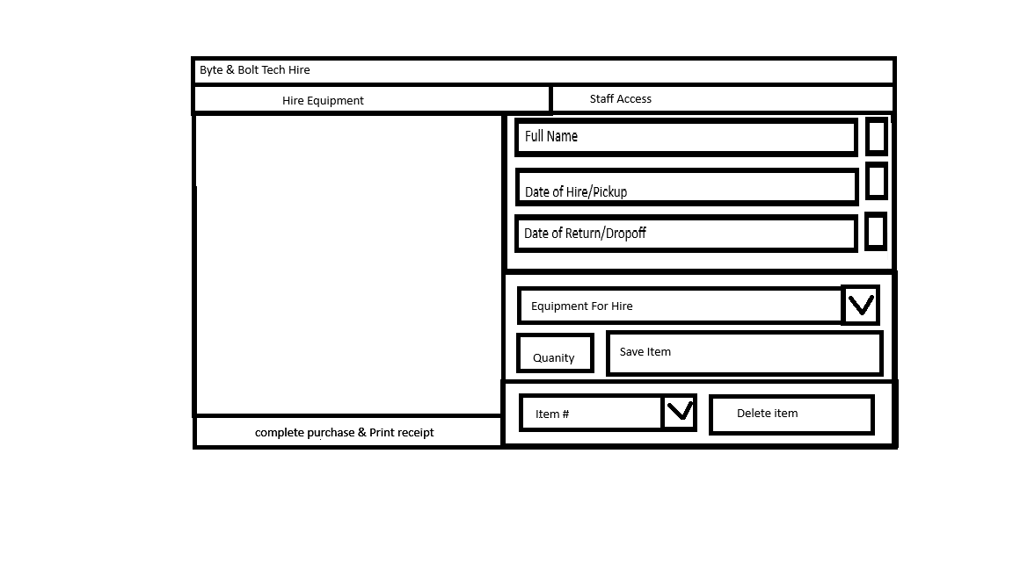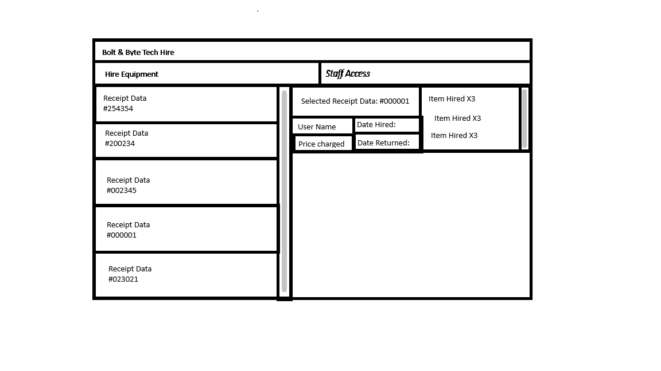
Concept 2

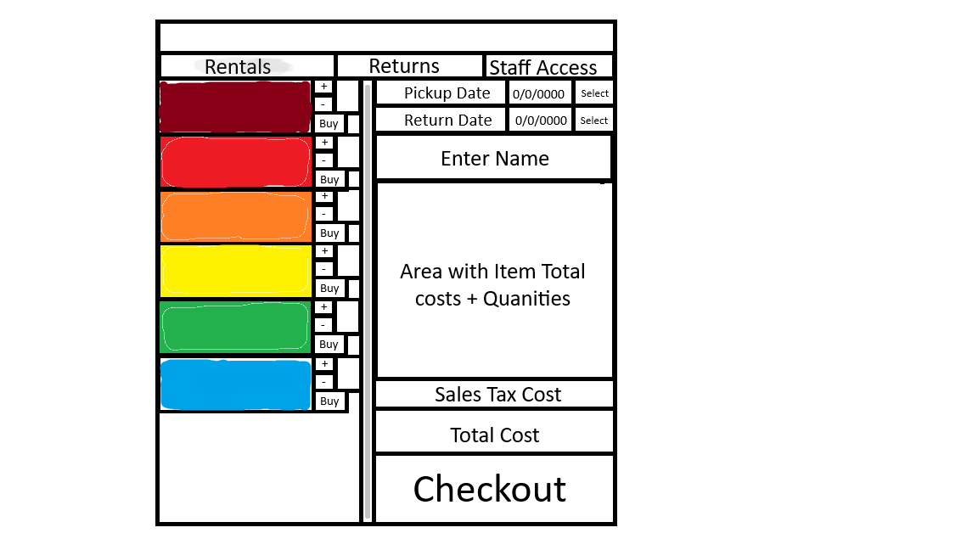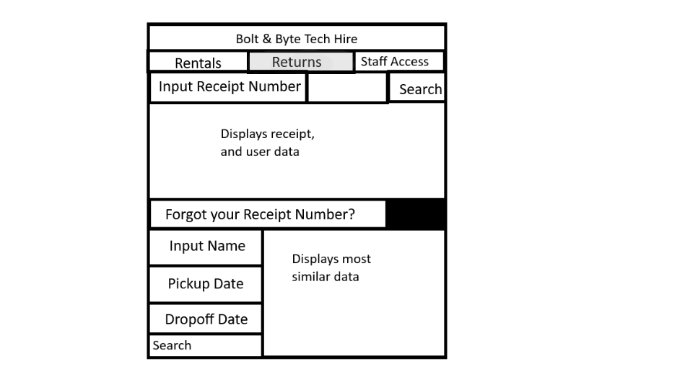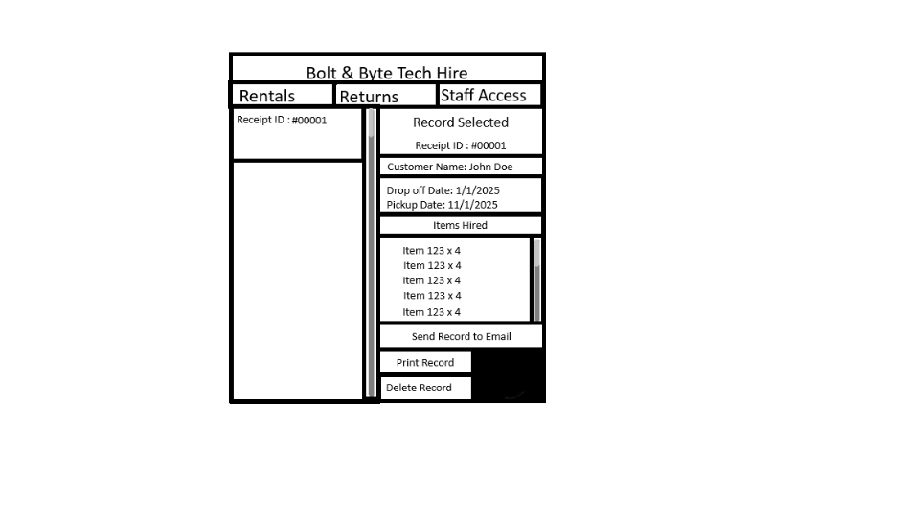

Concept 3

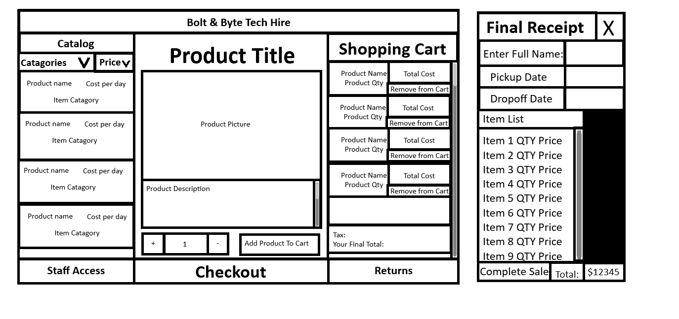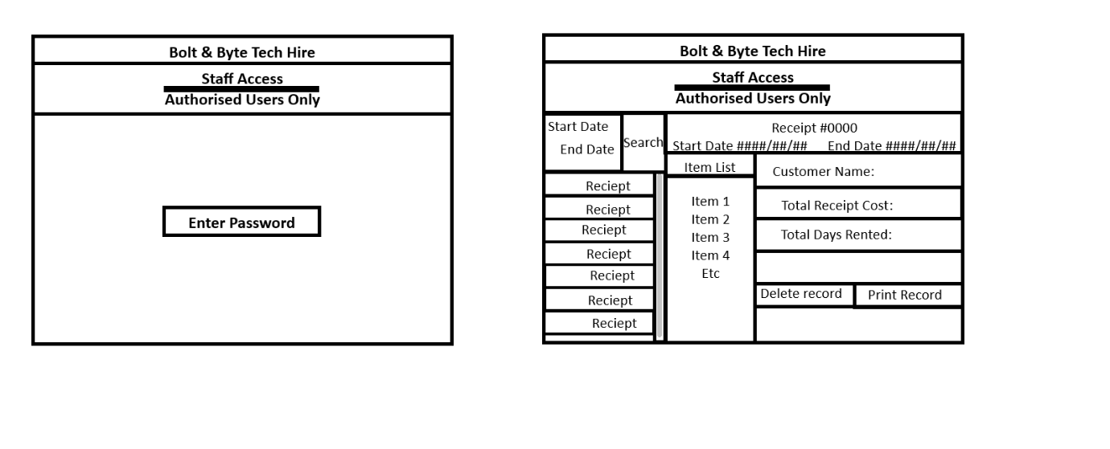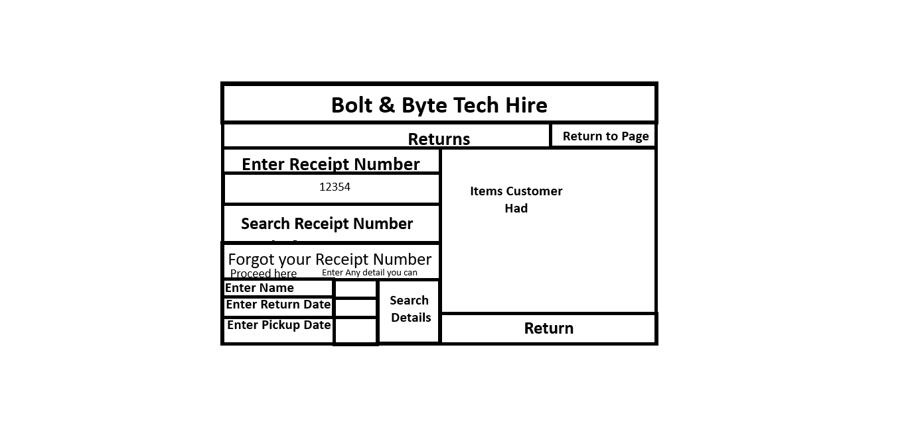

Final Concept

I will be continuing with Concept two. I have chosen this concept as I believe the sketch has just the right number of features that will provide me a challenge to program, and enough for it to feel ergonomic for the users.,

Flow chart

Project Management Tools:

Two Project Management Tools chosen along with justification note: You need to show a timeline of development:

I’ve chosen these two Project Management tools as Gantt Charts allow for me to create and visualise a timeline of my progress. I then chose Trello to use as it can allow me to setup tasks in a sticky note system that make it very easy to add and complete tasks, I’ve set for myself.
The final decider for my choice was the inclusion by both sites having a plugin that allows for integration between the two websites.

My Gantt Chart

My Trello Board
Decomposition Tools:

One Decomposition Tool chosen along with justification:

Decomposition Table-2PAD

Project Management Techniques (Methodologies):

AGILE

I Chose the Agile Project Management technique, I did this because this technique allows for me to rapidly iterate on my projects. I also chose this technique because of the need for us to collect feedback from potential users; this needing of feedback will always delay certain parts of the main project as I await for feedback but with agile I can still work on other sections like the backend of my project without issue.

Collaboration Tools:

Google Forms - justification
I will use Google Forms to receive feedback from users as I can freely share a questionnaire about a certain component I decide to trial and can also allow for extended feedback from users in case they have any other ideas.

(Add link here)

Version Control:

- Saving backup copies with a logical file naming system

(Add a snip from your file explorer/or other version control software of the versions you have created)

- using simple version control software applications (this can be GitHub, File Explorer or other)

Link to my Github Repo

Justify your Version Control Tools chosen:
I have chosen GitHub as my Version Control Tool, This is because GitHub is excellent for tracking each version and change I make to my project, along with this GitHub has a plethora of integration tools with coding platforms that allow for my code to be uploaded to GitHub when I save my data.

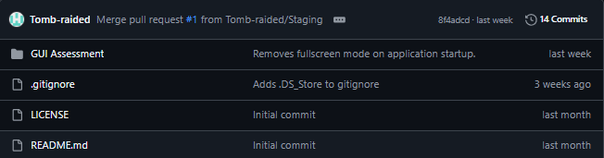

First Pull Request
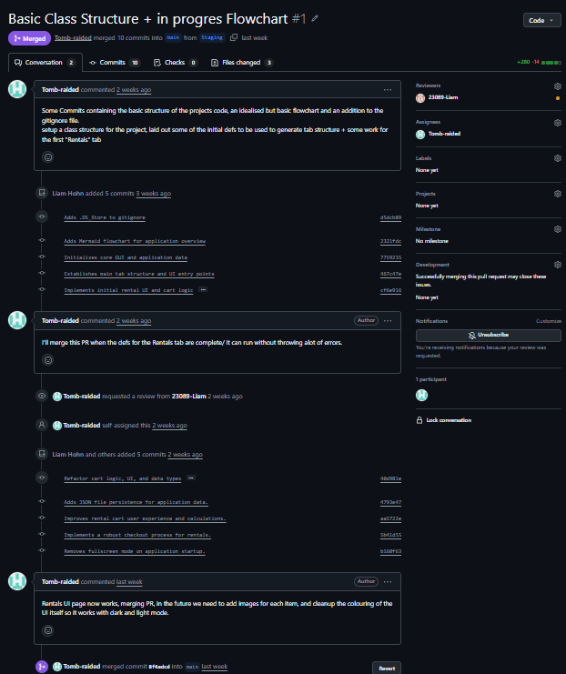

Component 1: Colour Scheme
Trialling : The change I was trialling was the colour/theme of my application to see what potential users may or may not like/enjoy when using the application.  (A, B, C are left to right respectively) | 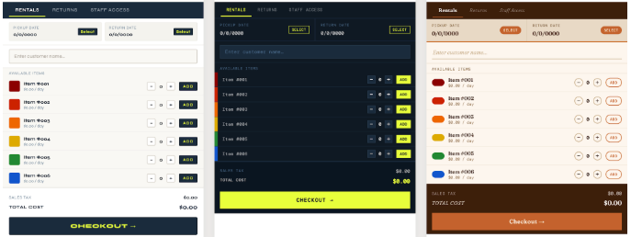
Evaluation of Response: | 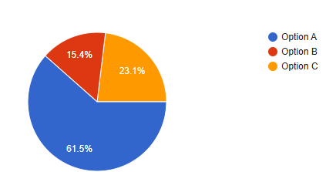  Out of each of the choices variant B was the least liked out of the three, with many users complaining about the colour scheme being too dark to easily use. Variant C was perceived much more positively than variant B, and while it doesn’t take the first spot of which variant was most liked, it seemed to have a few users who preferred it vastly more then other users. the Variant A was the most well received variant with a majority of users liking the contrasted buttons and the rainbow gradient of colours for each item.
Which did I choose and why? | I have chosen the colour scheme in variant A, this is because along with being the least negatively responded too, it also allows for a lot more freedom in changes that may come in the future if I decide to allow for the colour scheme to be changed by the users.

Component 2: Differing layout for Returns UI
Trialling: | 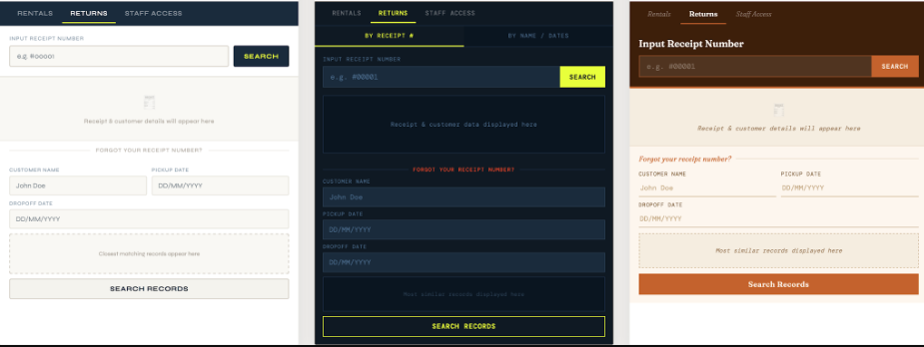
Evaluation of Response: | 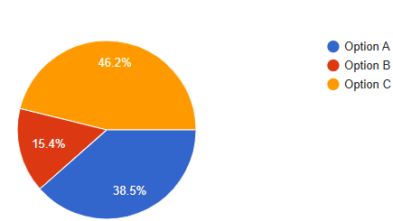
Which did I choose and why?

Component 3: Different Admin displays of user reciepts
Trialling: | 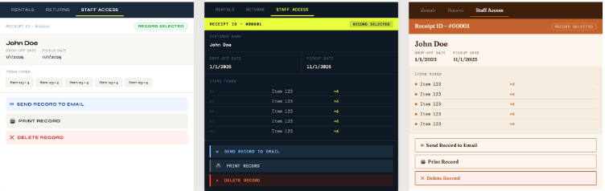
Evaluation of Response: | 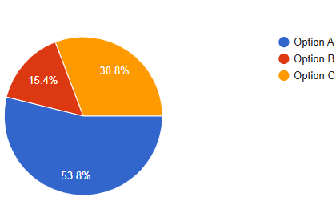
Which did I choose and why?

Final:

(Add snips below of your Final GUI interface after the trialling process)

Evaluation:

In the space below add critical reflection/evaluation of project management tools:

(Add answer here)

Reflect on the evaluation of trialling, testing and feedback e.g. Did the Technological Process (Iterative design process) help you with your project? If so, how?

(Add answer here)

Explain how addressing the Relevant Implications of your project helped in developing your outcome.

(Add answer here)

GRADE: N / A / M / E Students Name: Liam Hohn
Assessment schedule/Mahere Aromatawai: Digital Technologies & Hangarau Matihiko 91897 Use advanced processes to develop a digital technologies outcome
Evidence/Judgements for Achievement/Paetae | Evidence/Judgements for Achievement with Merit/Kaiaka | Evidence/Judgements for Achievement with Excellence/Kairangi
Use advanced processes to develop a digital technologies outcome. | Use advanced processes to develop an informed digital technologies outcome. | Use advanced processes to develop a refined digital technologies outcome.
The student has:  ◻ Concept designs  ◻ A Flow Chart  ◻ Used 2 recognised and appropriate project management tools and techniques to plan and manage the development of a digital technologies’ outcome.  ◻ Trello Board  ◻ Gantt Chart  ◻ Other………………….  ◻ Decomposed the digital technologies outcome into smaller components used 1 Decomposition Tools:  ◻ To Do Lists  ◻ Decomposition Table  ◻ Mind Map  Project Management Technique used:  ◻ Waterfall  ◻ Agile  Collaboration Tool used:  ◻ Google Docs/Forms  ◻ Interviews (with interview logs)  ◻ Emails  ◻ Survey Monkey  Version Control:  ☐ Clear folder and file names with version numbers  Trialling:  ☐ Broken their outcome down into a series of components. For each component they have created a piece of code and trialled it with feedback.  Evaluation Tool:  ☐ Provided a snip of their final GUI.  ☐ Provided a brief reflective summary of the development process  ☐ Explained at least three Relevant Implications (paragraph for each required) | The student has:  Project Management Tools:  ☐ Selected the most viable PM tools to use  ☐ Selected and justified the most viable Methodology to use  ☐ Provided evidence of using project management tools and techniques to effectively manage the development of a digital technologies outcome  Version Control:  ☐ Used version control tools to effectively manage the development of a digital technologies’ outcome  ☐ Each file is named appropriately with a version number and date.  ☐ They have created a GitHub and/or file explorer document with snips demonstrating version control  Collaboration/Trialling:  ☐ Trialled alternate ways of getting user input  ☐ Evaluated evidence from their trialling, testing and feedback to inform their decisions to update their project plan  ☐ Provided a critical evaluation of why they agreed/disagreed with their respondents on GUI design choices.  Evaluation of Trialling/Testing and Feedback Implications:  ☐ Provided a critical evaluation of PM tools  ☐ Evaluated the testing and trialling process appropriately, may have linked this process to improve the functionality of the digital technology’s outcome  ☐ Addressed relevant implications throughout the project | Reflection and Justification  ☐ Discussed how the PM tools guided or hindered the development process.  ☐ The student presents a reflective summary of how the information from planning, testing, and trialling of the components of their hire program assisted them to develop a high-quality outcome.  ☐ Provided annotated screen shots or detailed description of the changes they have made throughout the process and how feedback from the users and the testing process helped them to refine their program.  ☐ In-depth analysis of relevant implications throughout the project and evaluation
 | Grade | N | A | M | E
Comments:
Final grades will be decided using professional judgment based on a holistic examination of the evidence provided against the criteria in the Achievement Standard

